ASSIGNMENT: C4 Bonus

FILE: C4_ACT_katherto.pdf

DATE: 10 February 2016

BY: Kathryn Atherton

katherto

Joshua Hahn

Hahn28

Hannah Mackin Schenck

hmackins

SECTION: 03, 1:30-3:30

TEAM: 45

ELECTRONIC SIGNATURE:

Kathryn Atherton

Joshua Hahn

Hannah Mackin Schenck

The electronic signatures above indicate that the document submitted for evaluation is the combined effort of all team members and that each member of the team was an equal participant in its creation. In addition, each member of the team has a general understanding of all aspects of the document.

**TASK 1**

PART A:

Flowchart:

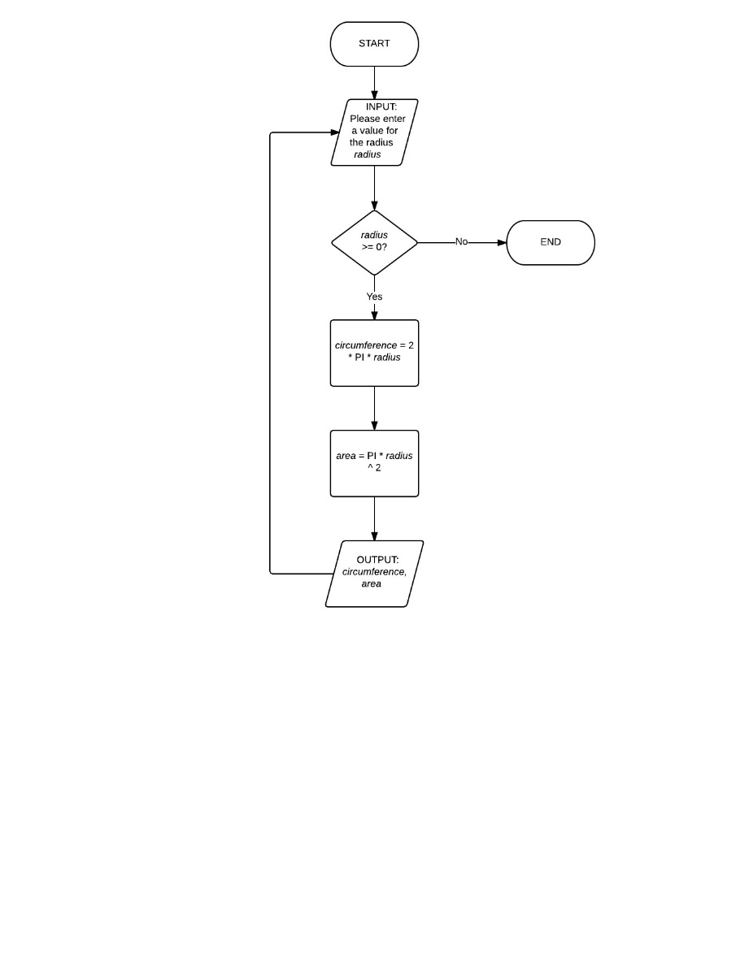

Code: C4_ACT_Task1a_katherto.c

PART B:

Code: C4_ACT_Task1b_katherto.c

1. If termination expression was based upon entering 0.0 or -1.0 instead of 0 or -1, then double comparison using fabs() would be necessary instead of using <= to compare the integers to a range of values.
2. We would modify the while condition to compare the input to 0.0 or -1.0 using floating point comparison.

PART C:

Code: C4_ACT_Task1c_katheto.c

1. The do while construct differs in that it runs through the execution once before checking. This can be a disadvantage in that even if a user inputs a value to exit the program, the program still runs through the execution statements before deciding whether or not to terminate.
2. While (i > 0) {

Printf(“%d \n”, i);

--i;

}

Do {

Printf(“%d \n”, i);

--i;

} while (I > 0);

**TASK 2:**

PART A:

Code: C4_ACT_Task2a_katherto.c

PART B:

Code: C4_ACT_Task2b_katherto.c

PART C:

Code: C4_ACT_Task2c_katherto.c

**TASK 3:**

PART A:

Flowchart:

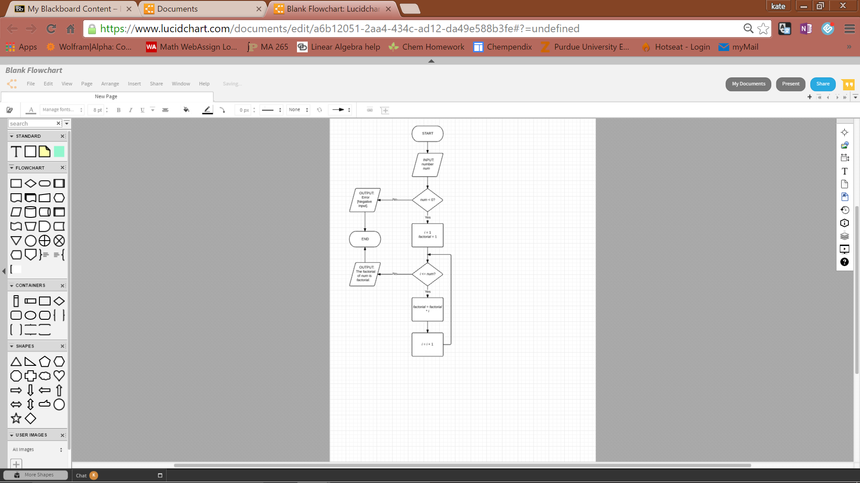

Code: C4_ACT_Task3a_katherto.c

PART B:

1. It is more appropriate to use a for loop for this task, as the number of iterations is known.
2. Yes, one could have used the while loop, as in C, they are fundamentally the same.

PART C:

Code: C4_ACT_Task3_katherto.c

**TASK 4:**

PART A:

Code: C4_ACT_Task4a_katherto.c

PART B:

1. Some trends in the system temperature over time are that the temperature does not always go directly to the desired temperature. Sometimes the temperature dips below/raises above the desired temperature before reaching it. Also, based on the difference in temperatures and the value of p, sometimes the loss of heat to the environment is so great that it only allows the temperature to drop.
2. There is a condition where the loop runs infinitely because of the constant heat loss to the environment. If the difference between the two temperatures is initially 3.0 and the p constant is 1.0, an infinite loop occurs.

PART C:

If the integral function was called instead of the proportional function, as used in PART A, one would expect that the control would approach the desired temperature more smoothly.

This program would fix the “droop” that caused the proportional control to run forever.